INSTANCE-1
Network Type | City | Sub City | Polling Engine
Access Network | HYD | Hyderabad, Ahmedabad & Warangal | HYD-MPE, HYD-APE1 & HYD-APE2
 | DELHI | Delhi & Ghaziabad | DEL-APE1
 | LUCKNOW | Lucknow
 | JAIPUR | Jaipur
 | VIZAG | Vishakapatnam, Kakinada & Rajahmundry | VIZ-APE1
 | VIJAYAWADA | Vijayawada, Eluru & Gunturu | VJW-APE1
 | NELLORE | Nellore & Tirupati | NLR-APE1
 | PUNE | Pune
Solarwind
ACT architecture

INSTANCE-2
Network Type | City | Sub City | Polling Engine
Access | BLR | Bangalore & Hosur | BLR-APE1 & BLR-APE2
 | CHENNAI | Chennai , Madurai & Trichy | CHN-APE1
 | COIMBATORE | Coimbatore | CBE-APE1
Core/IT/DC | JAIPUR | Jaipur | BLR-MASTER-PE  BLR-APE-CORE  BLR-APE-CORE-2
 | VIZAG | Vishakapatnam, Kakinada & Rajahmundry
 | VIJAYAWADA | Vijayawada, Eluru & Gunturu
 | NELLORE | Nellore & Tirupati
 | PUNE | Pune
 | DELHI | Delhi
 | HYD | Hyderabad & Ahmedabad
 | LUCKNOW | Lucknow
 | BLR | Bangalore & Hosur
 | CHENNAI | Chennai , Madurai & Trichy
 | COIMBATORE | Coimbatore
Video | BLR | Bangalore | BLR-MASTER-PE  BLR-APE-CORE  BLR-APE-CORE-2
 | NELLORE | Nellore
 | VIZAG | Vishakapatnam

ACT architecture
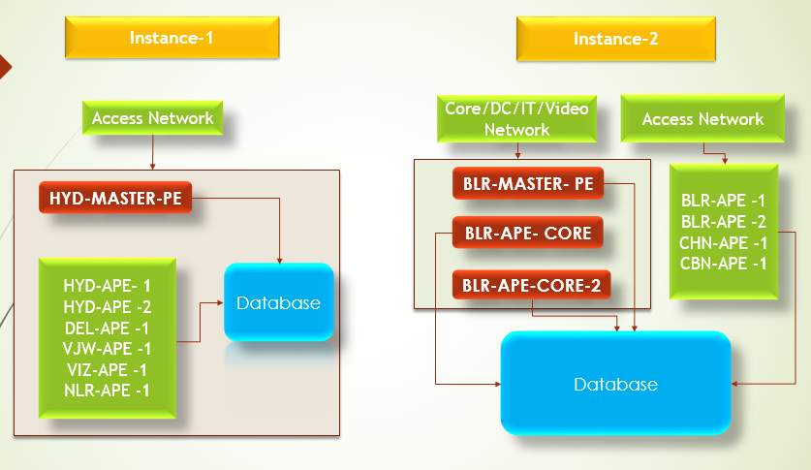

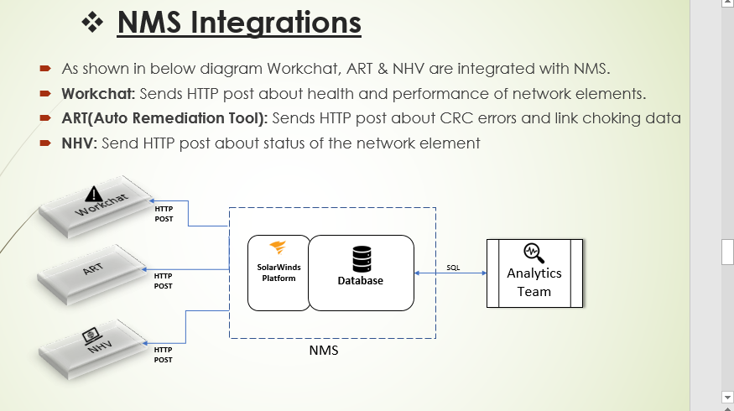

Teams dependent

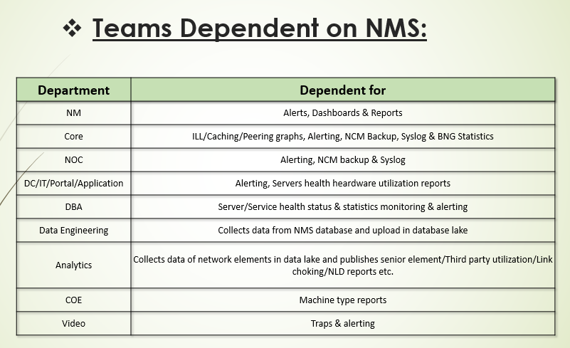

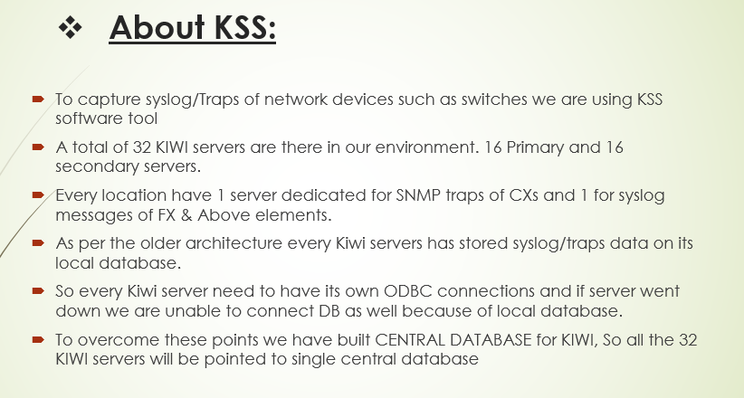

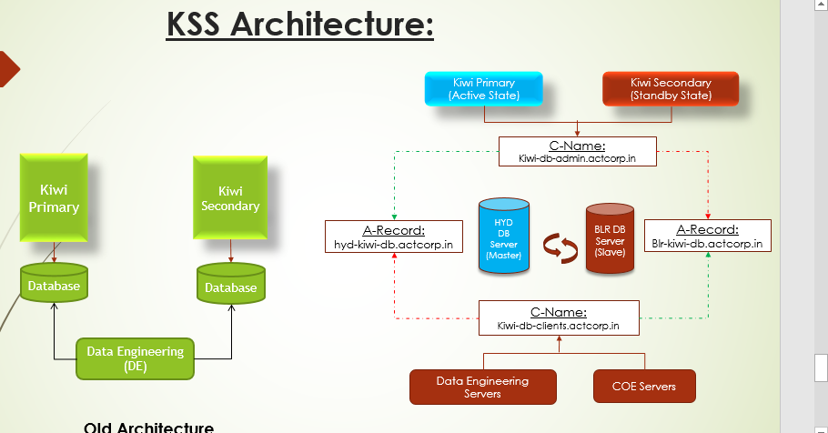

Node management in solarwind-
In SolarWinds, node management involves adding, managing, and monitoring network devices (nodes) like servers, switches, and routers. You can access this functionality through the "Manage Nodes" view in the SolarWinds Platform Web Console, allowing you to add, edit, and filter nodes for monitoring and configuration management.
Here's a breakdown of key aspects of node management in SolarWinds:
1. Accessing Node Management:
- Navigate to the SolarWinds Platform Web Console.
- Click on "Settings" > "Manage Nodes".
- Alternatively, click "Manage Nodes" in the All Nodes resource.
2. Adding Nodes:
- Click "Add a Node" to manually add a node for monitoring.
- Specify the node's hostname or IP address, polling method, and credentials.
- Select the statistics and resources to monitor on the node.
- Optionally, select custom pollers and review/adjust device properties, including SNMP settings, polling intervals, and custom properties.
- Click "OK, Add Node" to finalize the process.
3. Managing Nodes:
- Searching and Filtering:
Use the search field to find specific nodes or interfaces, and filter by properties like IP address, operating system, or custom properties.
- Grouping:
Group nodes based on various criteria (e.g., location, department) for easier management.
- Editing Properties:
Access the "Edit Properties" option to modify node settings, including SNMP settings, polling intervals, and custom properties.
- Maintenance Mode:
Enable maintenance mode for nodes to temporarily disable alerts and prevent unexpected issues during maintenance activities.
- Exporting Node Lists:
Export the node list to a CSV file for offline analysis or reporting.
- Managing Node Connectors:
Manage node connectors, including agent and non-agent types, to ensure proper monitoring.
4. Node Management in Specific SolarWinds Products:
- Network Configuration Manager (NCM):
NCM helps manage, organize, and track changes to network devices, which are known as nodes in NCM.
- Network Performance Monitor (NPM):
NPM provides hardware health overviews for monitored devices, allowing you to quickly view the current node count, filter by device status, and drill down to find unavailable or offline nodes.
- Server Configuration Manager (SCM):
SCM focuses on managing server configurations, allowing you to assign configuration profiles to nodes and monitor server configurations.

Managing Alert Actions:
  - In the Action Manager, you can edit, enable, disable, and delete alert actions.
  - Assign pre-configured actions to multiple alerts to streamline your alert management process.
- Pausing and Resuming Alerts:
  - You can pause all alert actions if needed, for example, during maintenance.
  - Navigate to Alerts & Activity > Alerts, and use the Pause actions of all alerts option
1
.

